6115-MAHENDRA INSTITUTE OF ENGINEERING AND TECHNOLOGY
ENVIRONMENTAL MONITORING
Team Members:
✯ M.SARATHI
✯ S.OMKAR SATYAVAN SURYAVANSHI
✯ M.PUGAZHENTHI
✯ S.SANJAI
✯ E.SAKTHIVEL
✯ M.RAGHUVARAN
Mentor Name:
✯ M.SANTHANARAJ
Abstraction:
Environmental monitoring is the process of collecting and analyzing data to track changes in the natural environment. involves measuring various parameters such as air quality, water quality, soil condition, and biodiversity to assess state of the environment and potential threats.
lntroduction:
Environmental monitoring is the process collecting and analyzing data on the condition of the environment. It the measurement and assessment of various physical, chemical, biological factors in the air, water, and other natural resources The purpose of environmental monitoring is to identify changes or trends in environment, evaluate the effectiveness policies and regulations, and potential risks and hazards.
Importance of environmental monitoring:
Environmental monitoring is essential that helps us keep tabs health of the environment, air, water, and soil quality. By monitoring these critical aspects, we can quickly identify any negative trends or changes that could be harmful to human health or ecosystems. The primary objectives of environmental monitoring include identifying sources of environmental pollution, tracking the movement of pollutants, monitoring changes in environmental conditions over time, assessing the effectiveness of pollution control measures, and providing data for decision making and policy development.
Types of environmental monitoring:
✯ air monitoring
✯ air quality monitoring
✯ emission monitoring
✯ surface water quality monitoring
✯ water monitoring
✯ soil monitoring
✯ soil erosion monitoring
✯ biological monitoring
Air monitoring:
Air monitoring is a crucial of environmental monitoring. It involves the use of various tools to measure and evaluate the quality of the we breathe. The process involves collecting samples air from different locations, analyzing the samples to identify pollutants, interpreting the results to understand the level of pollution in the. Air monitoring is essential for identifying sources of pollution, tracking in air quality, and developing effective strategies for reducing air pollution levels. With the increasing awareness of the impact human activities on the environment, air monitoring has become an essential tool for ensuring that the air breathe is safe and healthy.
Air quality monitoring:
Air quality monitoring is a aspect of environmental monitoring, with concerns about air pollution and resultant health impacts. It involves the measurement and analysis of various pollutants in the air, including particulate matter, nitrogen oxides, sulfur dioxide, among others. With the help of advanced and equipment, scientists and environmentalists can collect data on air quality,trends, and identify sources of pollution. This information can then be to implement policies and practices aimed at reducing harmful emissions, protecting health, and ensuring a healthy environment.
Emissions monitoring:
Emissions monitoring is an aspect of environmental monitoring. It involves the measurement and analysis of air pollutants and greenhouse gases released into the atmosphere by different sources, such as industrial facilities, transportation, and energy production. Emissions plays a crucial role in assessing the of human activities on the environment and human health. It helps to identify potential risks and environmental hazards, as well as to develop appropriate mitigation measures and policies. Emissions monitoring data is also used for regulatory purposes, to ensure compliance with environmental regulations and standards, and to track progress towards emission reduction goals.
Surface water quality monitoring:
Surface water quality monitoring involves examining the chemical, physical, and biological characteristics of natural water resources as rivers, lakes, and streams. It helps gauge the level of contamination present in these vital sources of water and to identify potential threats could compromise their quality. Surface water quality involves the collection of water samples at strategic along a water body, are then tested for various parameters such as pH, dissolved oxygen, and nutrients, among others. Monitoring results are used to support evidence-based-making and to inform effective management strategies to protect water quality and safeguard public health.
Water monitoring:
Water Monitoring is a crucial of environmental monitoring, as water a vital resource for all beings. Monitoring water quality helps ensuring the safety of aquatic life, wildlife, and humans. The involves measuring physical chemical, and biological parameters water bodies such as lakes, rivers, and. This data is used to identify potential pollutants, track changes in water quality, and develop effective strategies for water resources. Water monitoring programs often carried out by governmental agencies, non-profit organizations, and institutions. These programs help in identifying trends and detecting emerging issues affecting water quality. Overall, monitoring plays a critical role in protecting human health and preserving the natural environment.
Soil monitoring:
Soil monitoring is an essential aspect of environmental monitoring. It the regular testing of soil and health to identify changes and trends over time, as well potential of contamination. The soil is a vital component of the ecosystem providing the foundation for plant growth and supporting numerous forms of wildlife Soil monitoring helps to ensure that the soil remains healthy and productive protecting ecosystem as a whole. It is commonly performed in areas where agricultural activities, operations, and other human activities are likely pose a risk of soil contamination or degradation.
Soil erossion monitoring:
Soil contamination and erosion are major environmental concerns that require continuous monitoring. Soil contamination monitoring involves analysis of soil samples for the presence of pollutants, such heavy metals, pesticides, and petroleum products. This is important contaminated soil can negatively impact human health, quality, and overall environmental health. Soil erosion monitoring, on other hand, involves the measurement of soil loss due to natural human-induced causes. This is in mitigating the effects of erosion on soil fertility, crop, and ecosystem functions. Both soil contamination and erosion monitoring are critical components of environmental monitoring aimed at preserving and improving soil.
Biological monitoring:
Biological monitoring is a method used to assess the health of ecosystems by analyzing the presence and abundance of various organisms. This of monitoring is particularly useful because it can provide information about long-term changes in an environment, as well as-term responses to specific disturbances. Biological indicators, such as certain species of fish or insects, be used to assess the quality an ecosystem and to detect changes over time.
Methods of environmental monitoring:
Environmental monitoring refers to the of collecting and analyzing data about the physical, chemical, and compounds present in the environment. This is important for determining the state of the environment and identifying any potential that could harm human health the ecosystem. To carry out the monitoring process, methods are employed. These can range from sampling air, water, and soil to analyzing from remote sensors. Other methods include using imagery, measuring pollution levels, and conducting wildlife surveys.
Remote sensing:
Remote sensing and in-situ monitoring are two important methods for environmental monitoring. Remote sensing involves use of satellites, aircraft, drones or other devices to gather data from a distance. It offers comprehensive and wide information about a large area in short time, making it ideal for monitoring larger-scale. In contrast, in-situ monitoring involves collecting data directly from a specific or site, using sensors and other instruments. This method provides accurate and high-resolution data but can be-consuming and limited in scope By combining these two approaches, environmental monitoring can achieve both comprehensive coverage and detailed insights.
Laboratory analysis:
Laboratory analysis is a critical component of environmental monitoring. It involves the testing of various samples from the environment to determine the presence and level of pollutants and other contaminants. These samples can soil, water, air, or biological specimens The analysis helps to identify potential sources of pollution and assess the effectiveness of existing control measures. Furthermore, laboratory analysis can provide that is to inform policy and regulatory decision-making.
Application of environment:
Environmental monitoring is a critical tool for assessing the state of our, including tracking changes in weather patterns, water quality, air, and other variables that impact the health our ecosystems and our communities. The applications of environmental monitoring are and wide-ranging, from helping scientists to identify the sources of and develop strategies for reducing it, to informing policy decisions and more sustainable practices. Environmental monitoring can be used monitor the health of wildlife populations, track the spread of invasive, and monitor the effects of climate change on different habitats.
Industrial sector:
The industrial can have a significant impact on the environment through its use of and production. Industrial activities such as manufacturing, mining, and construction can lead to pollution and waste, as well as the emission of greenhouse gases. In years, there has been a growing emphasis on sustainable industrial and reducing the environmental impact of industrial activities Environmental monitoring in the industrial sector involves the systematic collection and analysis data to measure environmental indicators such as air and water quality, levels, and soil contamination.
Urban En:
The "Urban En" refers to the environmental concerns and challenges faced by urban areas. As world becomes increasingly urbanized, impact of cities on the environment grows, highlighting the importance of and managing urban environmental issues. Urban areas are responsible for a portion of global greenhouse gas emissions, leading to air pollution, climate change, and health issues.ization also leads to def, loss of biodiversity, and water scarcity which pressure on ecosystems and threaten the sustainability of cities.
Natural Area Management:
Natural Area Management is an aspect of environmental monitoring. It involves the preservation, protection, management of natural areas like forests, wetlands, grasslands, and nature reserves. The focus is on ensuring the sustainability of the natural environment protecting it from human activities and promoting ecological processes such as poll, seed dispersal, and nutrient cycling. Natural Area Management to maintain biodiversity, prevent habitat loss, and preserve rare endangered species. It also provides opportunities for education and recreation while the importance of conservation.
Data management and analysis:
Data management and analysis are critical components of environmental monitoring. Monitoring programs generate vast amounts of data and it is essential to store, manage and analyze data to derive insights and make informed decisions. Robust data management procedures ensure data integrity quality control. It involves activities such as data collection, validation, processing analysis, storage, reporting.
Public engagement and Awarness:
As technology continues to advance, it has become easier and more-effective to monitor environmental conditions Smart sensors and data analysis tools are now available to provide real-time environmental data and help identify potential risks. At the same time there has a growing public awareness of environmental issues and a demand for more and accountability from governments and organizations In response, many governments organizations have launched public engagement and awareness campaigns to inform citizens about environmental concerns and the steps being taken to address.
Proposed System:
In this proposed model the climatic changes are frequently monitoring through IOT using sensor nodes. Internet of Things (IoT) is a recent communication paradigm, in which the objects will be equipped with microcontrollers, transceivers and suitable protocol stack that will make them to communicate with one another and with user. This paper designs a prototype of wireless environmental monitoring system to upload information from array of sensors to the database. This application allows us to observe or measuring the environmental parameters from anywhere in real time. This system consist of main three modules namely sensor nodes, the wireless communication and the web server. The sensor nodes in remote location collect the information from surrounding environmental conditions and send the data wirelessly using Arduino microcontroller and ESP8266 Wi-Fi module to the server. This paper presents a system that can be used to measure the toxic gases in surrounding area like Industrial area by using various sensor nodes. All sensors are connected on the arduino microcontroller and the status of the sensors is send to the control section continuously. The data uploading is done by ESP 8266 Wi-Fi module. The data is updated on internet.
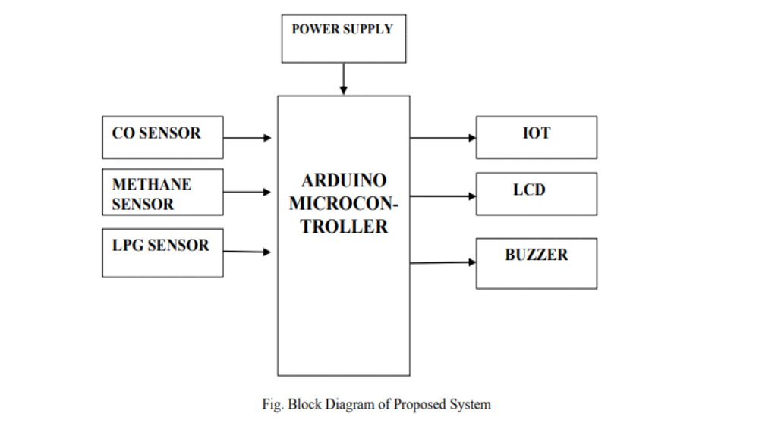
Wi-Fi module is managed by the Arduino Sketch. The Arduino sketch is written, compiled and loaded to the Arduino board using Arduino IDE.From the above model, process is divided in 5 layers. The environmental parameters which are to be measured are introduced in layer 1. Study of the characteristics and features of sensor devices is in layer 2. In layer 3, there is decision making on sensing, measuring and fixing the threshold value, periodicity of sensitivity, timing, space and Led.
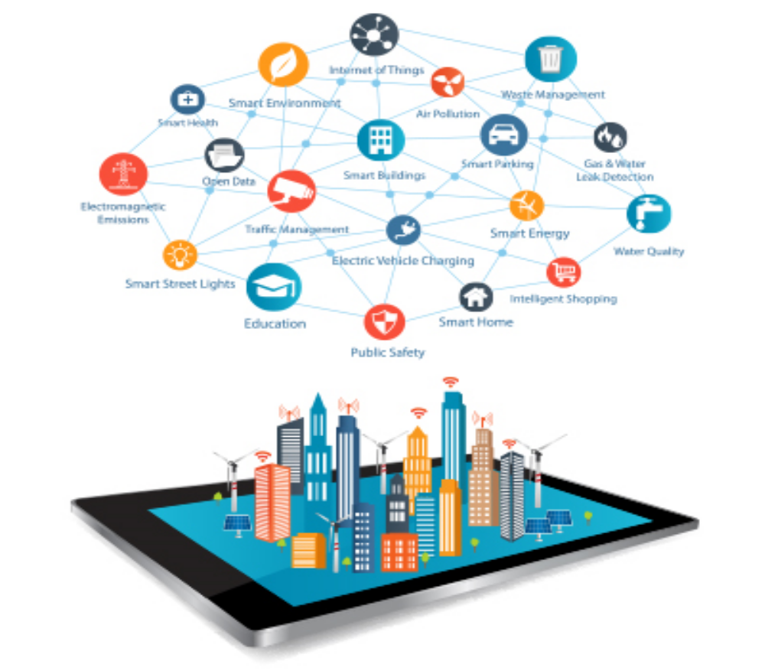
Challenges in Environmental monitoring:
The challenges in environmental monitoring are multiple – improving sample throughput; handling a variety of gaseous, liquid and solid matrices; reliably sampling a wide range of VOCs and SVOCs… the list goes on!
This will be my first time at these shows, so I’m looking forward to going along and meeting the major players in the UK environmental scene, as well as seeing the latest developments in monitoring technology to tackle emerging challenges.
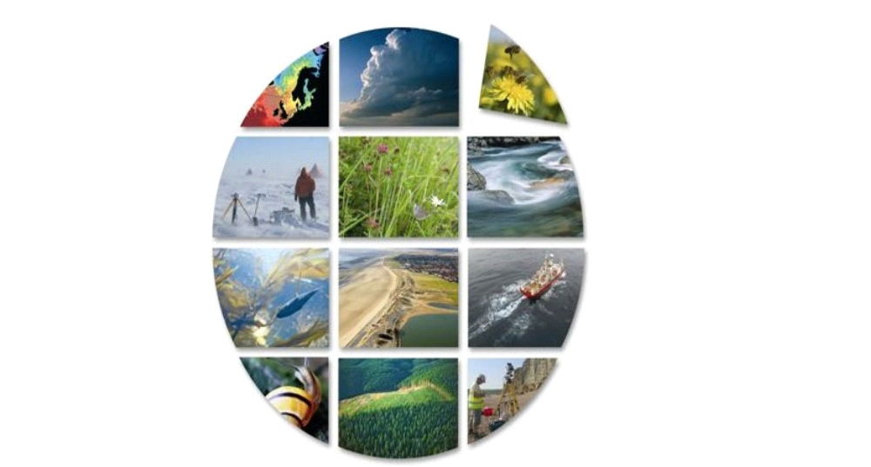
Implementation pollution control measures:

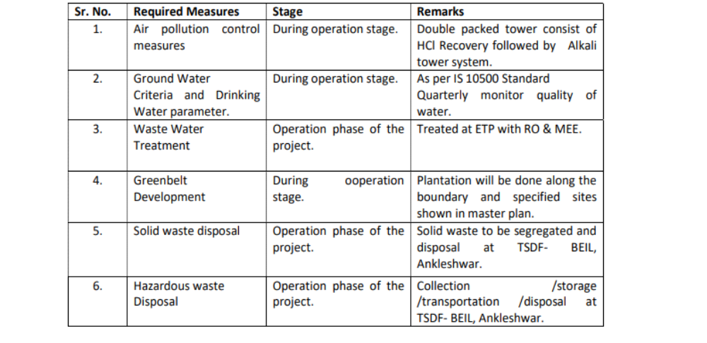
INSTALLATION:
Setting up an environmental monitoring system involves several steps, including choosing the right sensors, hardware, software, and deployment strategy. Here's a general guide on how to install an environmental monitoring system
Define Your Monitoring Objectives: Determine the specific environmental parameters you want to monitor, such as temperature, humidity, air quality, water quality, soil conditions, etc.
Select Sensors and Hardware: Choose appropriate sensors and instruments based on your monitoring objectives.
Consider factors like sensor accuracy, calibration, measurement range, and connectivity options (e.g., wired or wireless).Decide on data loggers or microcontrollers to collect and process data.
Data Acquisition System: Set up a data acquisition system to collect data from the sensors.This could be a microcontroller (e.g., Arduino, Raspberry Pi), data logger, or dedicated data acquisition hardware.
Connect Sensors: Physically install the sensors at the chosen monitoring locations.Ensure sensors are correctly calibrated and connected to the data acquisition system.
Data Storage and Analysis: Set up a data storage system, which could be a local database or cloud-based service.Implement data analysis tools to process and interpret the data.
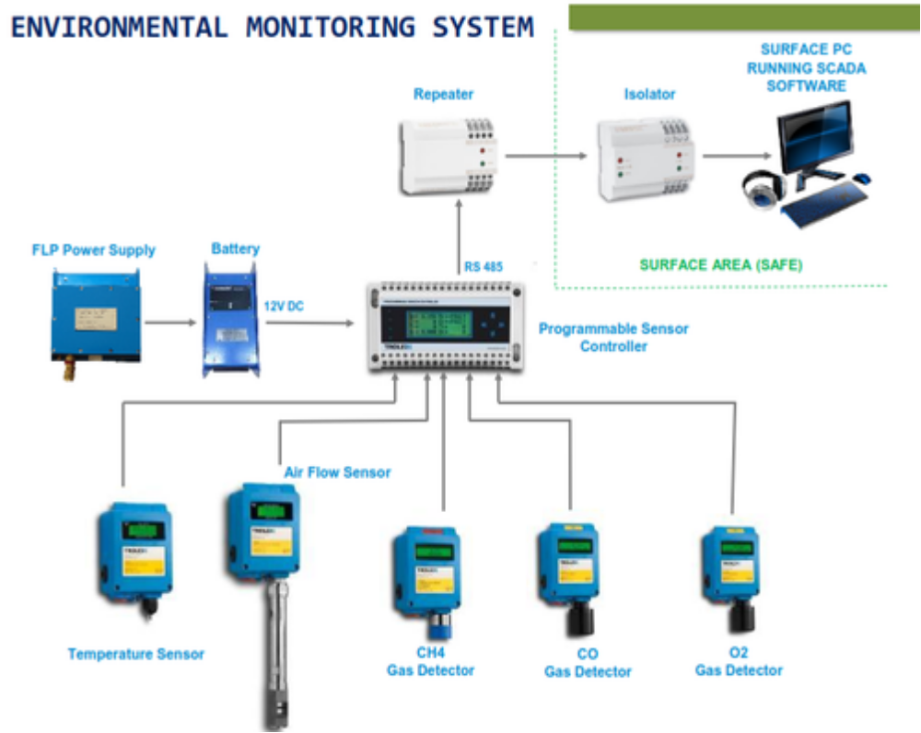
PLANNING:
Identify Environmental Parameters: Determine which specific environmental parameters you need to monitor. This could include temperature, humidity, air quality, water quality, soil conditions, biodiversity, pollution levels, and more.
Select Monitoring Locations: Identify the geographic locations or areas where monitoring is needed. Consider factors like environmental sensitivity, proximity to pollution sources, and accessibility.
Budget and Resources:Determine the budget and resources required for your monitoring program. This includes costs for sensors, data acquisition systems, personnel, data analysis tools, and ongoing maintenance.
Sensors and Equipment Selection:Choose appropriate sensors and monitoring equipment based on your objectives and the environmental parameters you're monitoring. Consider factors like sensor accuracy, calibration, measurement range, and connectivity options.
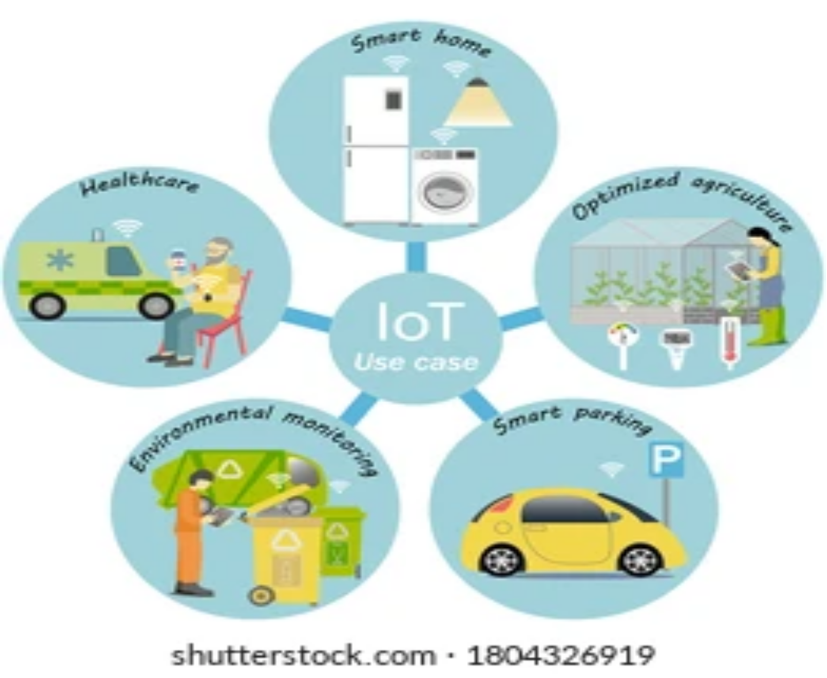
CONTROLLING:
environmental monitoring controlling involves managing and overseeing the environmental monitoring program to ensure it operates effectively and efficiently. This typically includes tasks such as setting up sensors, configuring data collection and analysis processes, ensuring data accuracy, and responding to various environmental conditions. Below are some key steps for controlling an environmental monitoring system
Sensor Configuration:Install and configure the sensors you need to monitor the specific environmental parameters relevant to your project, such as temperature, humidity, air quality, or water quality. Ensure they are correctly connected and calibrated.
Data Collection: Set up data collection mechanisms to gather data from your sensors. This might involve using sensor-specific libraries or interfaces.
Data Quality Assurance:Regularly verify the quality and accuracy of collected data. This may involve calibrating sensors, checking for anomalies, and addressing issues promptly.
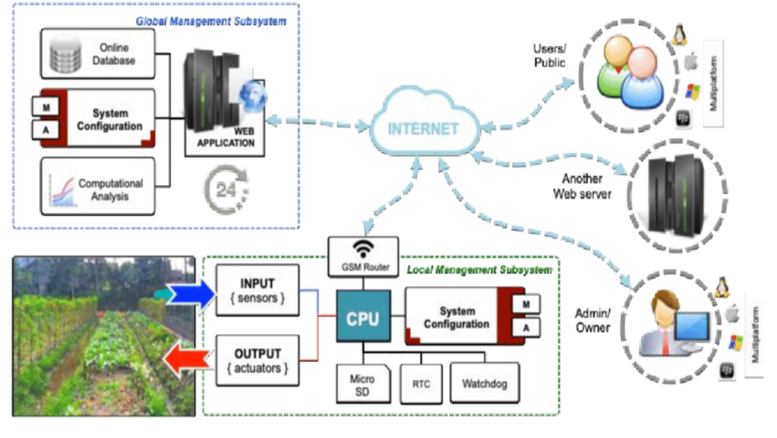
EXECUTION:
program code:
import time
import random
import csv
# Function to simulate a temperature sensor reading
def read_temperature():
# Simulate a temperature reading between 0 and 40 degrees Celsius
return round(random.uniform(0, 40), 2)
# Function to record environmental data to a CSV file
def log_environment_data(data, filename):
with open(filename, 'a', newline='') as file:
writer = csv.writer(file)
writer.writerow(data)
# Main program loop
if __name__ == "__main__":
data_filename = "environmental_data.csv"
try:
while True:
# Read temperature data
temperature = read_temperature()
# Get current timestamp
timestamp = time.strftime("%Y-%m-%d %H:%M:%S")
# Store the data in a list
data = [timestamp, temperature]
# Log the data to the CSV file
log_environment_data(data, data_filename)
print(f"Timestamp: {timestamp}, Temperature: {temperature}°C"
# Wait for a specified interval (e.g., 5 minutes)
time.sleep(300)
except KeyboardInterrupt:
print("Monitoring program stopped.")
FUTURE ENGINEERING MODEL:


The future of environmental monitoring is likely to be shaped by a combination of technological advancements, increased awareness of environmental issues, and the need for more comprehensive and real-time data to address pressing environmental challenges. Here are some key trends and developments that we can expect in the future of environmental monitoring.
Advancements in Sensor Technology: One of the most significant drivers of change in environmental monitoring is the development of more advanced and affordable sensor technologies. Miniaturization and improved sensitivity of sensors will enable real-time data collection at a granular level, covering a wide range of environmental parameters, from air and water quality to soil health and biodiversity.
IOT and Connectivity:The Internet of Things (IoT) will continue to play a pivotal role in environmental monitoring. IoT devices, such as remote sensors and drones, will enable the collection and transmission of data to central repositories, allowing for real-time analysis and decision-making. This connectivity will facilitate the monitoring of remote and inaccessible areas.
Big Data and Analytics: With the influx of data from numerous sensors, the future of environmental monitoring will rely heavily on big data analytics and machine learning algorithms to process, analyze, and extract insights from the massive amounts of data. This will lead to a more data-driven and predictive approach to environmental management.
Citizen Science: The involvement of the public in environmental monitoring will likely increase. Citizen science projects and applications will empower individuals to contribute data and observations, enhancing data coverage and raising awareness of environmental issues. Mobile apps and online platforms will play a crucial role in facilitating citizen participation.
Satellite and Remote Sensing: Advances in satellite technology and remote sensing will continue to provide valuable information for large-scale environmental monitoring. This includes monitoring deforestation, land use changes, climate patterns, and disaster response. Smaller and more affordable satellite constellations will improve data accessibility.
Environmental Health Monitoring: As public awareness of environmental health concerns, such as air and water quality, grows, there will be an increased demand for real-time monitoring systems that provide individuals with information about the immediate environmental risks they face.
TRAINNING:
raining for environmental monitoring involves a combination of academic education, practical experience, and specialized skills. The exact requirements and training pathways may vary depending on the specific field of environmental monitoring and the country in which you plan to work. Here are some general steps and considerations for training in environmental monitoring.
Educational Background:
Undergraduate Degree: Most environmental monitoring positions require at least a bachelor's degree in a relevant field. Common majors include environmental science, biology, chemistry, geology, ecology, or a related field.
Skills and Training:
Laboratory Techniques: Learn laboratory techniques for analyzing environmental samples, including water, soil, and air.
Instrument Operation: Familiarize yourself with the operation of various monitoring instruments and equipment, such as spectrometers, gas analyzers, or remote sensing devices.
Data Analysis: Develop skills in data analysis and the use of software tools for processing and interpreting environmental data.
Geographic Specialization:Depending on your career goals, you may want to consider specializing in a particular geographic region or type of environment, such as marine, terrestrial, urban, or rural environments.
EVALUATION:
Evaluating environmental monitoring programs and efforts is crucial to ensuring their effectiveness, improving data quality, and making informed decisions related to environmental management and policy. The evaluation process involves assessing various aspects of the monitoring program. Here are key elements to consider when evaluating environmental monitoring.
Objective Assessment:Clearly define the goals and objectives of the monitoring program. Evaluation should focus on whether these objectives are being met.
Data Quality:Examine the accuracy, precision, and reliability of the collected data. Assess the calibration and maintenance of monitoring equipment.Check for any biases or errors in data collection, analysis, and reporting.
Cost-effectiveness:Evaluate the cost of the monitoring program in relation to the benefits it provides. This may involve a cost-benefit analysis to determine the program's efficiency.
Technological Advancements:Consider whether the monitoring methods and technologies used are up-to-date and whether there are opportunities for improvement through the adoption of new technologies.
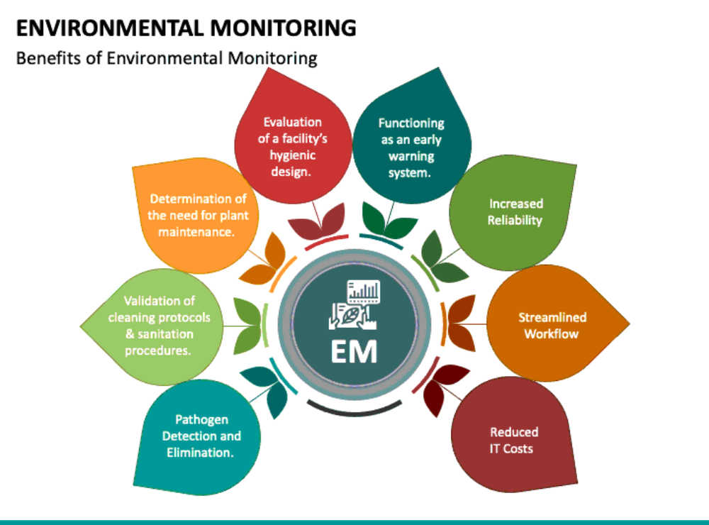

Regular evaluation and feedback loops are essential for adapting and improving environmental monitoring programs. These evaluations can help address emerging environmental challenges and enhance the quality and utility of monitoring data for informed decision-making and environmental protection.
Conclusion:
Environmental monitoring is critical to the protection of human health and the environment. As the human population continues to increase, as industrial development and energy use continues to expand, and despite advances in pollution control, the continued production of pollution remains inevitable.

THANKYOU!!!

